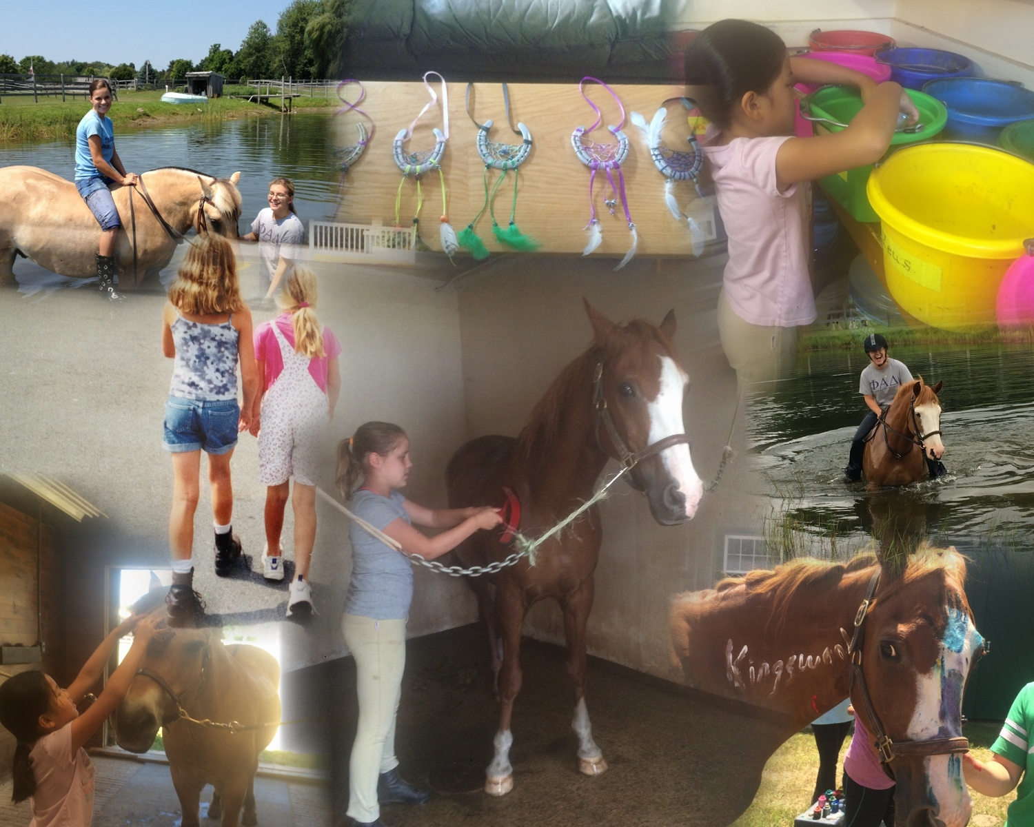  Beginner camp July 10-14  Intermediate camp August 7- 11  Horseback riding summer camp  Looking for a great way to spend your summer vacation? Come join us at Kingswood Farm for a fun filled week of horsing around! We offer a safe, educational, and fun filled atmosphere where your child will learn all about horses. Activities include: riding lessons, learning the basics of horse care, horse safety, crafts, pony painting, and more. Please contact us for further information  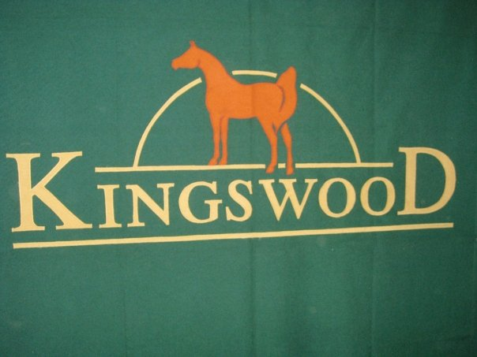 | SUMMER PROGRAM  ────  OFFERING 2 CAMP SESSIONS  ────  HORSEBACK RIDING LESSONS  ────  WELCOME ALL AGES AND RIDING ABILITIES  ────  CAMP HOURS 9AM-3PM  Kingswood farm  8 Freeman Street,  East Kingston,  NH, 038327  603 642-3722  http://kingswood-farms.com/

